*Lab task no 06*

*SUBMITTED TO: ENG SIR HAMAYON*

*SUBMITTED BY: BARKATULLAH*

*ROLL NO: 48*

*REG NO: 22MDSWE241*

*DEAPARTEMENT: C S E*

*Sir I am FATA student ,and at that lab task i was absent , because I have gone to home to bring migration certificate and DMC ,so kindly accept my this lab task .*

*Lab task no 01*

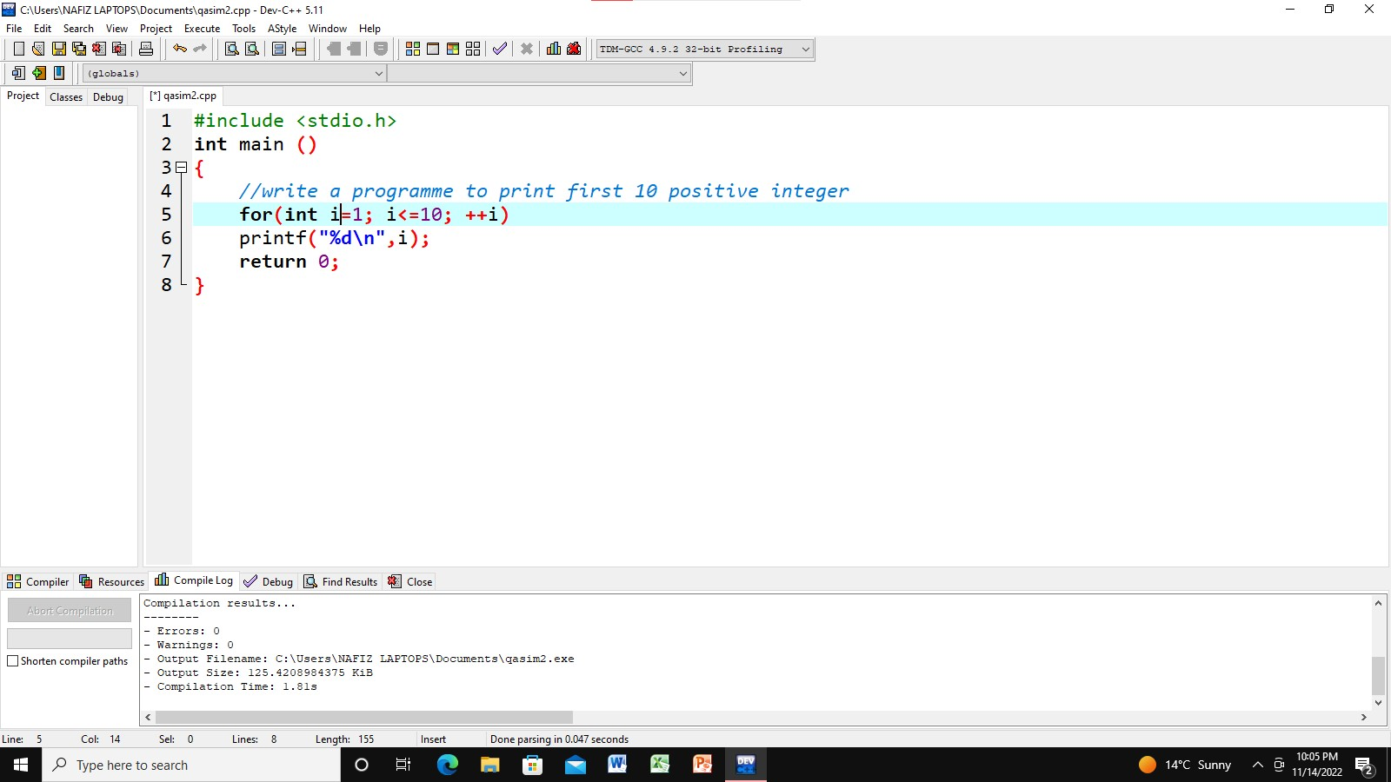

*Output*

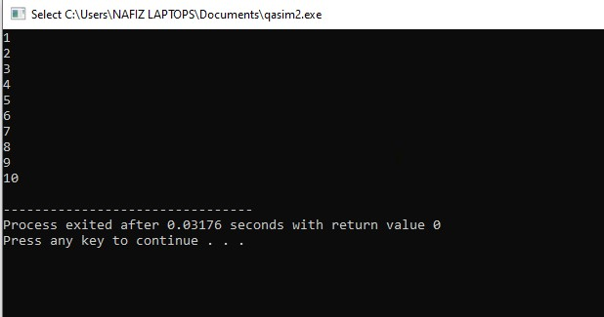

Input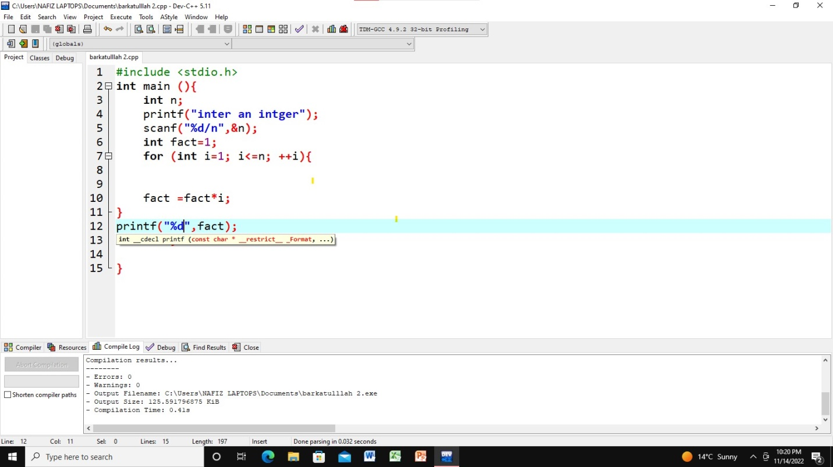

Output

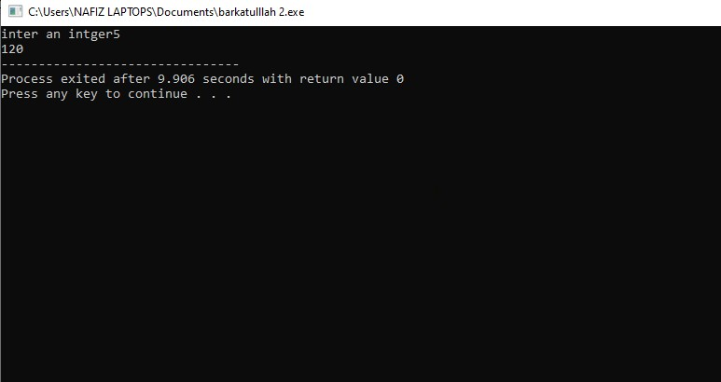

Labtask no 03

Input

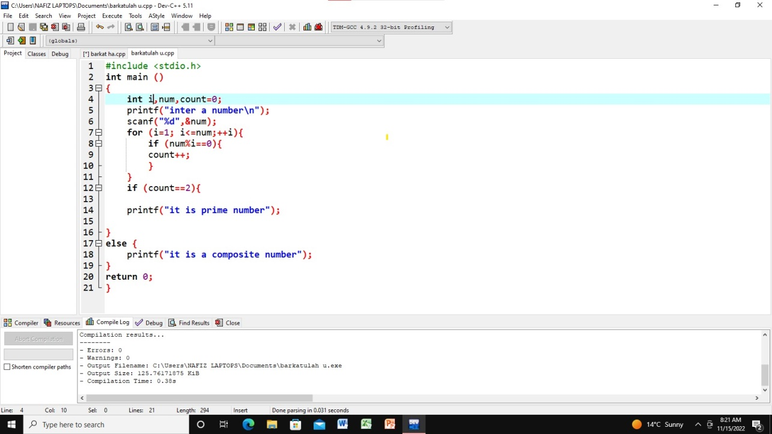

Output

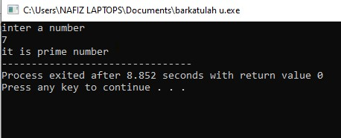

Labtask no 06

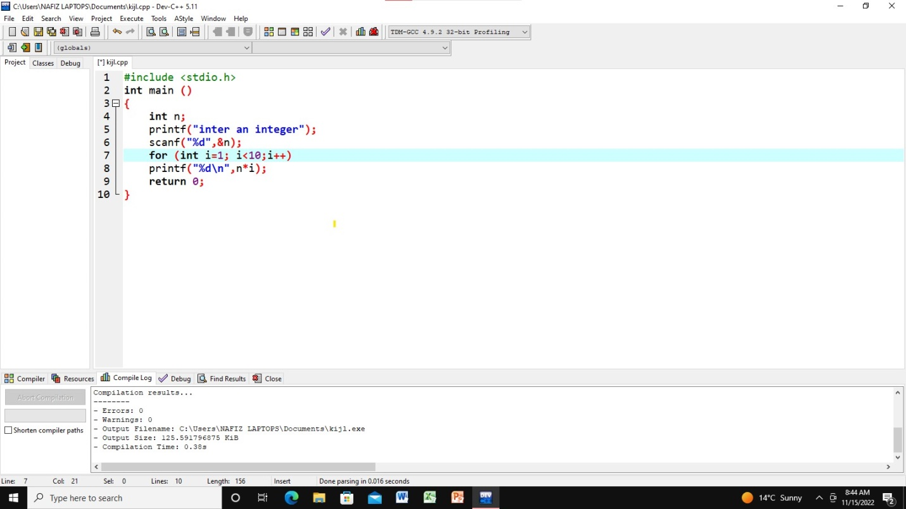

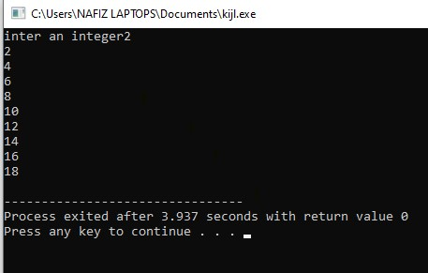

Labtask no 8

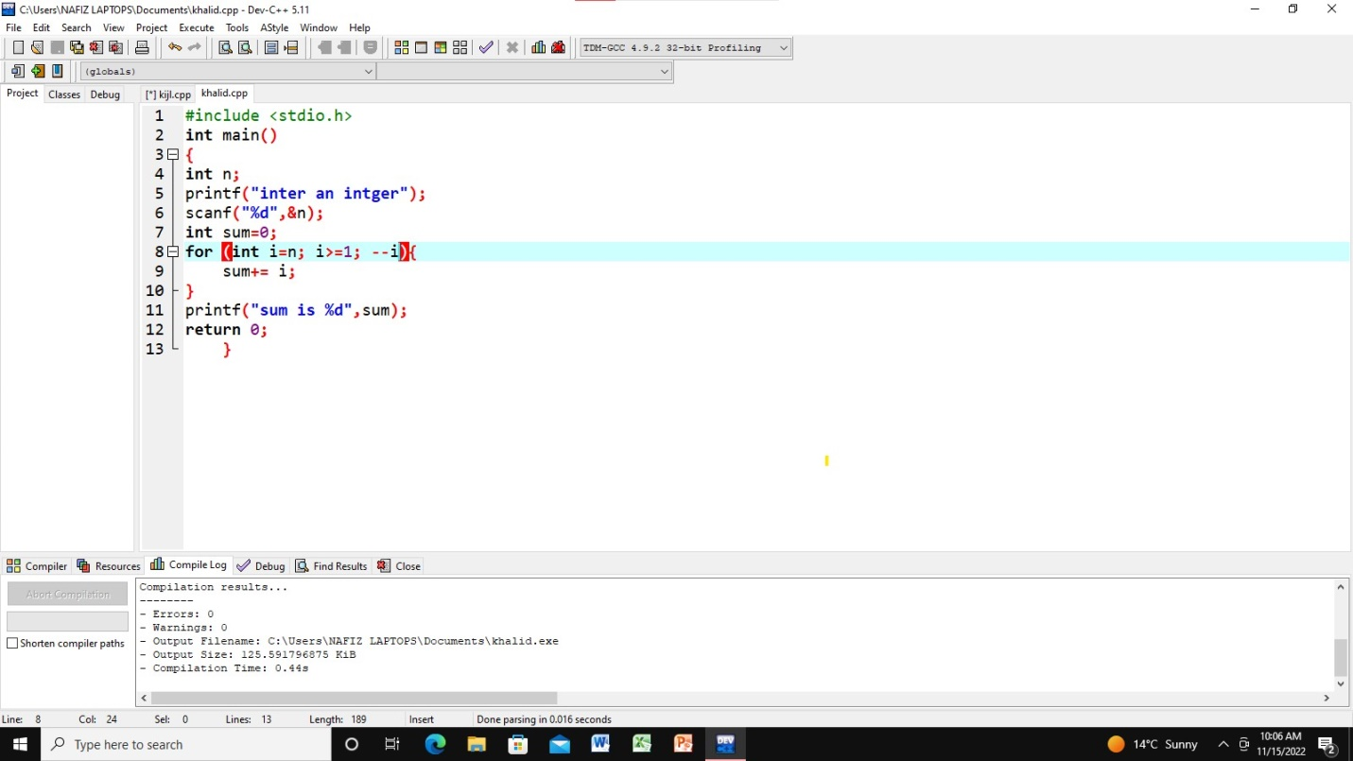

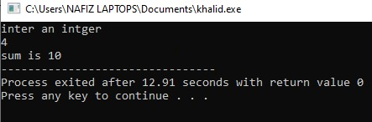

**Labtask no9**

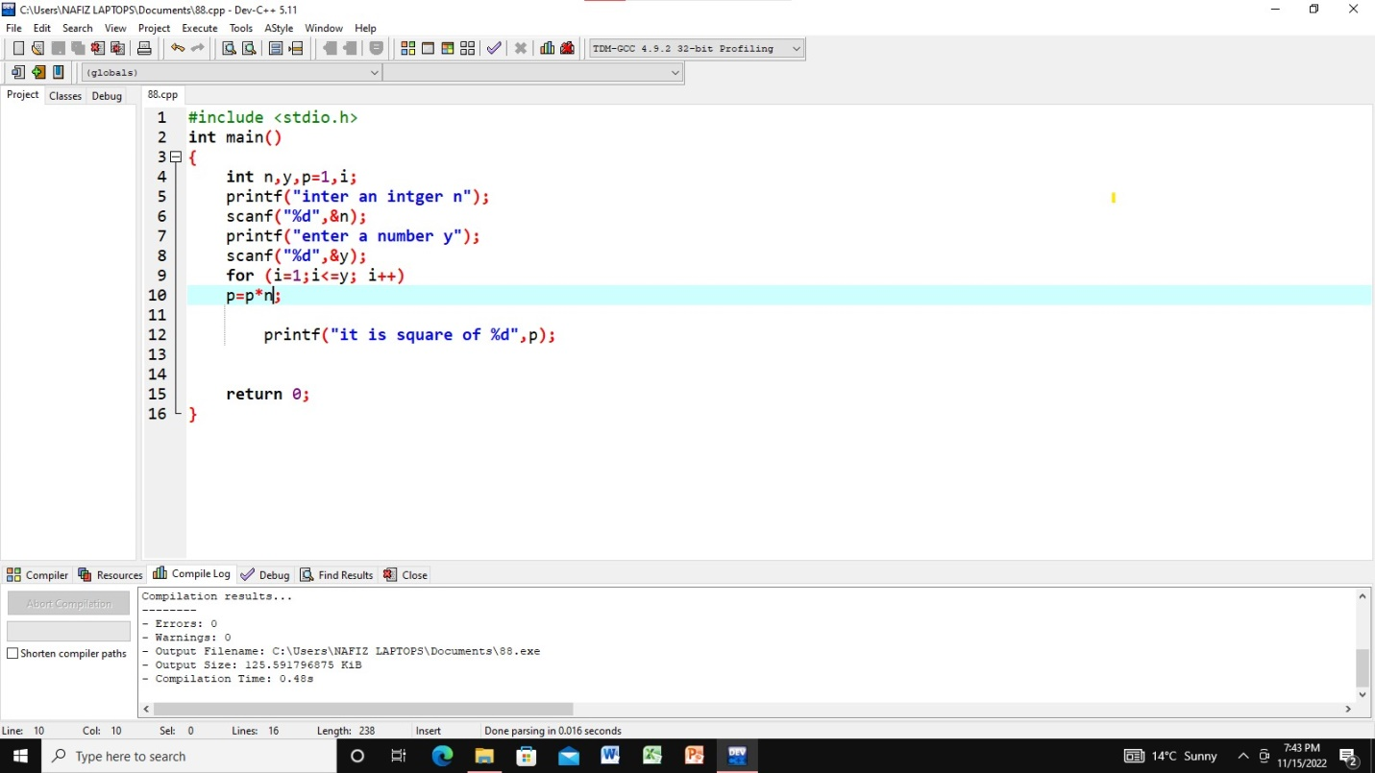

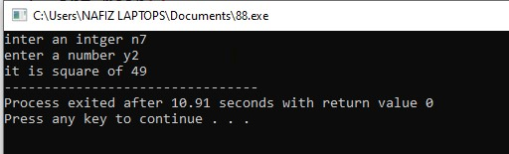

**Labtask no 10**

